**Allen Island Field Trip: Marine Debris**

**INTRODUCTION**

This is the fifth year of a marine debris survey. Allen Island is a private island located in southeast Muscongus Bay (Figure 1), previously owned by painter Betsy Wyeth.

**Figure 1.** Map indicating location of Allen Island. Map data ©2017 Google, United States

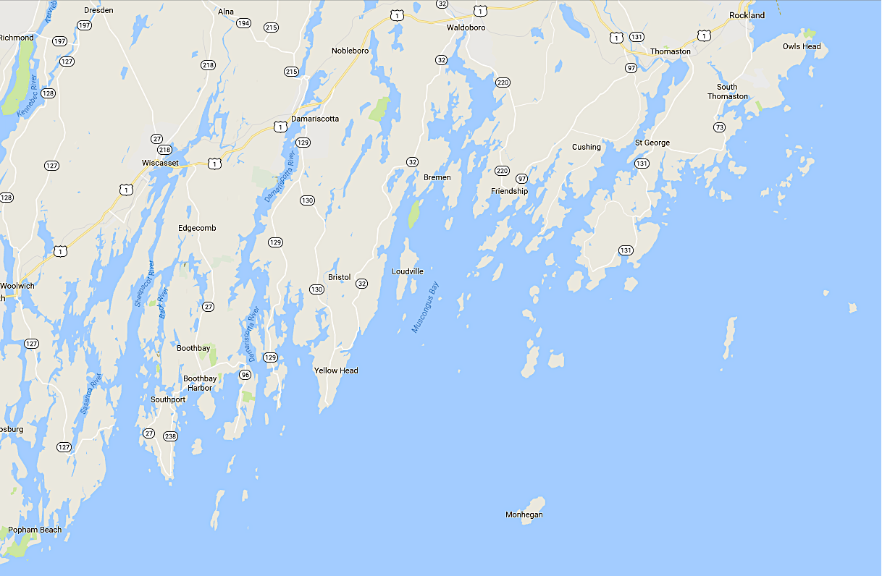

2 miles

The purpose of this survey is to chart changes in movement and types of debris over time and space. As such, you will have access to the 2016, 2017, 2018 & 2019 data sets.

The assessment for this field trip will be a group effort report in the following structure:

Introduction, Methods, Results and Discussion. Note that results and discussion will be separate sections in this report.

Throughout this assessment, consider possible sources of error. Remember to include units, figure legends and labels. For maps and images, this includes scale bars and usage rights or attributions where appropriate.

In the introduction, be sure to include at least one hypothesis on the distribution of marine debris, based on what you are measuring and/or what has been measured in the past. And explain the basis for this hypothesis.

Please include the raw data, in an appendix or separate file.

**METHODS**

This shoreline methodology is adapted from NOAA’s marine debris survey protocol: <https://marinedebris.noaa.gov/noaa-marine-debris-shoreline-survey-field-guide>

This document is a useful reference and provides more details of the methodology.

**1. Site description**

For each sample site, characterization is necessary to give context to the data collected. For annual surveys such as this, good characterization is important to allow accurate tracking of changes over time. It is worth remembering that storm events can change shoreline morphology over time.

This survey has four sample locations (Figure 2).

**Figure 2.** Satellite image of site locations. Imagery ©2017 Google, Data SIO, NOAA, U.S. Navy, NGA, GEBCO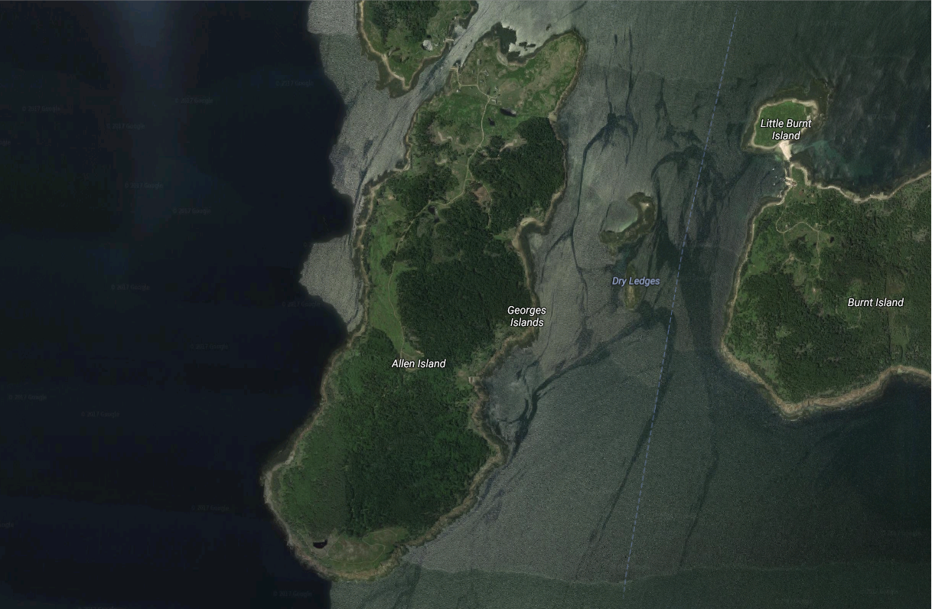

Station 4

Bunkhouse beach

Betsy's beach



1000 ft

Station 3

For each of these sites, include a description of land use and geographical features such as freshwater outflows, local land use and distance to settlements. Potential sources of debris and features that may affect debris distribution are particularly valuable to record. Other features to note include identification and uniformity of the primary substrate type (sand, cobble, etc.), the tidal range and distance (if applicable), a description of the first barrier at the back of the shoreline section (dunes, vegetation, etc.), and the aspect of the shoreline. Copious photographs are useful to collect for descriptive purposes.

**2. Macro debris (>2.5 cm)**

**a) Defining sampling methodology**

A transect is defined as straight line or narrow section through an object or natural feature or across the earth's surface, along which observations are made or measurements taken. Transects run perpendicular to the shoreline section from water’s edge at the time of sampling to the back of the shoreline, which is defined as location of the first barrier or primary substrate change (Figure 3).

**Figure 3.** Shoreline section (100 m) displaying perpendicular transects from water’s edge at low tide to the first barrier at the back of the shoreline section. Red circles indicate marked GPS coordinates. Shoreline width determines location and number of GPS coordinates. Figure not to scale.

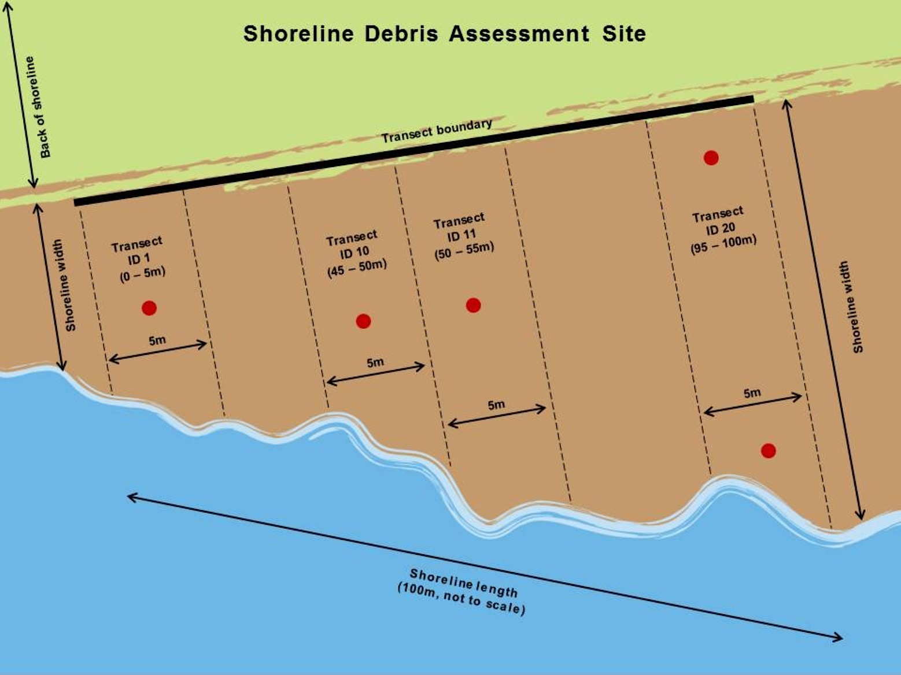

Where there is an intertidal substrate zone substrate change, the chosen end barrier should be at least to the high wrack line. It is important to clearly note what definition is used. Where there is debris above the back barrier such as storm debris, this may be recorded separately.

**b) Transect methodology (Ideally, surveys should be done within 3 hours of low tide.)**

A minimum of four transects is required for each site. For reference, the permanent reference points for each site are: Bunkhouse beach, a granite square post marking the back left corner of the transact facing the ocean; Betsy’s Beach, a spruce tree at the right edge of the site facing the ocean; Station 3, a spruce tree at the right edge of the site facing the ocean; Station 4, none.

i) Use surveyor's measuring wheel to mark selected transects with flags. Each transect should be 5 m wide. The center point of each transect should be 10 m from the next.

ii) Record ancillary data prior to the debris survey; length of each transect from water’s edge to first barrier, time, season, and date of last survey, description of recent storm activity, current weather conditions, and the number of individuals conducting the transect survey. If these characteristics are consistent between transects on a survey event, they need only be recorded on one data sheet.

iii) Walk each transect, tallying debris items according to material type and subcategory (see data sheets). Macro debris is defined as 2.5 cm in size (~1 inch) or larger. Large macro debris is defined as 30 cm (~ 1 ft) or larger, and should be recorded in the large items section of the sheet. Include information on debris type, status of the large item (sunken, stranded, or partially buried), the latitude and longitude of the item, and the approximate debris size.

Any item partially within a transect should be tallied. Items should not be tallied twice if transects are adjacent. If an item is blown into a transect mid- survey, it is tallied only if the surveyor has not yet surveyed the section of the transect where the item is located. Multiple fragments of what may have originally been a whole item should be tallied separately. If one fragment is recognizable as a specific item, for example a remnant of a plastic beverage bottle, it should be recorded as such provided that the remnant is at least 50% of the original item. Items that do not fall under a specific subcategory or are unclear can be entered into the “other” category at the end of each material section, with a brief description in "notes". Items that are composed of multiple material types should be recorded according to the most abundant material that makes up the surface of the item. Digital photographs should be taken of unidentifiable items, as well as other debris items or markings of interest. Place a lined ruler next to the debris item to establish a size reference. It is also a good practice to take a photo of each transect surveyed, and record photo ID numbers on the data sheet.

Include survey data sheets as an Appendix in the report.

**RESULTS**

1. Calculate debris concentrations for each individual transect surveyed (a minimum of four per survey).

2. Take the mean of the concentrations at each transect to calculate an overall site concentration (± standard deviation) for that date.

Calculate macro-debris concentration (number of debris items/m2) per transect by the equation below:

C = n/(w * l)

C = concentration of debris items (number of debris items/m2)

n = of macro-debris items observed

w = width (m) of shoreline section recorded during sampling (i.e. length of transect from water’s edge to back of the shoreline)

l = length (m) of shoreline sampled (i.e. transect width)

3. What patterns can be detected in your results? How do they compare to previous years?

**DISCUSSION**

This section is for putting results in a wider context. What explanations are there for the patterns seen in the results? Possible sources of debris? Think about the oceanography and weather of coastal Maine. How does this study link into the wider marine debris issue in the Gulf of Maine and beyond? Finally, what recommendations would you make for future surveys?

**Appendix 1 - Equipment required for Marine debris survey**

|  |  |  |  |
| --- | --- | --- | --- |
| Surveyor's tape | Marking flags | Clipboards | Pencils |
| Data sheets | Digital camera | Ruler |  |

**Appendix 2 - Learning outcomes:**

1. Practical fieldwork skills
2. Data recording and analysis
3. Contributing to annual survey
4. Dataset comparison
5. Linking observations to a wider issue

**Appendix 3 – Grading**

The following tables explain how this assessment will be graded.

Table A3. 1. Grading rubric

|  |  |
| --- | --- |
| Report is in required format |  |
| Introduction (15 %) | Purpose of experiment is included |
| Information is relevant |
| Hypothesis is included |
| Method (20%) | Method clearly stated and reproducible |
| All steps and units included. |
| Results (20%) | All required data from all sites is present, including ancillary information. |
| Identification of debris distribution patterns within and between sites |
| Comparison between 2021 and previous years’ data |
| Sources of error identified   1. within 2021 survey 2. between 2021 and previous years’ |
| Discussion (20 %) | Explanation of debris distribution   1. within sites 2. between sites 3. over time |
| Link to marine debris as a wider issue |
| Suggestions for methodology improvements included |
| Data presentation (20 %) | All data is included and correctly labeled |
| Graphs have correctly labeled axis with units and legends, where present |
| Maps and images include scales and usage rights, where appropriate |
| Figures and tables are referred to in the text |
| Appendix (5 %) | All data is included and data sheets are present and legible |

Table A. 3.2 Grading system

|  |  |
| --- | --- |
| Grade | Requirement |
| A | Excellent command of knowledge  High level of skill development |
| B | Good command of knowledge  Advanced development in most skills |
| C | Basic command of principles  Basic skill development |
| D | Lacks command of some principles  Lacks some basic skills |
| F | Hasn’t learned a thing |

**Appendix 4 – Data from 2016 survey**

Table A4.1**.** General information of the four surveyed beaches. The surveyed area on Betsy’s Beach was separated into Area 1 (A1) and Area 2 (A2), each 15m wide. The shore length was measured under the tidal level at the time of survey. The width was the distance from water’s edge to back of shoreline at the time of survey.

|  |  |  |  |  |  |
| --- | --- | --- | --- | --- | --- |
| *Site* | *Starting Time (p.m.)* | *Shore Length (m)* | *Width (m)* | *Substrate Type* | *GPS Coordinates* |
| *Bunkhouse Beach (Station 1)* | 1:00 | 40 | 16.5 | Cobble | 43º52’36’’N  69º18’43’’W |
| *Betsy’s Beach (A1) (Station 2)* | 1:30 | 32 | 24 | Cobble | 43º52’19’’N  69º19’1’’W |
| *Betty’s Beach (A2) (Station 2)* | 1:24 | 23 | 30 | Cobble | 43º52’19’’N  69º19’1’’W |
| *Station 3* | 2:15 | 80 | 40 | Cobble | 43º52’14’’N  69º18’33’’W |
| *Station 4* | ~3:00 | / | / | Rocky | 43°51'22.5"N 69°19'06.6"W |

Table A4.2. Marine debris concentrations (n/m2) by transect and site with means and standard error.

|  |  |  |  |
| --- | --- | --- | --- |
| Marine debris concentrations (macro-debris items/m2) | | | |
| Transect | Bunkhouse Beach | Betsy’s Beach | Station 3 |
| 1 | 0.3 | 0.3 | 0.5 |
| 2 | 0.6 | 0.4 | 0.5 |
| 3 | 0.1 | 0.1 | 0.1 |
| 4 | 0.3 | 0.2 | 0.6 |
| Mean ± Std. Dev. | 0.33 ± 0.2 | 0.25 ± 0.1 | 0.43 ± 0.2 |

Table A4.3 Marine debris distribution by material. Glass is not shown in table because none was found, but was included in initial search.

|  |  |  |  |  |  |  |  |  |
| --- | --- | --- | --- | --- | --- | --- | --- | --- |
| Macro-Debris | | | Site 1 | Site 2 | Site 3 | Site 4 | Total | % macro-debris category & % total |
| Plastic | Plastic fragments | Hard | 11 | 10 | 41 | 0 | 62 | 14.0 |
| Foamed | 8 | 11 | 20 | 0 | 39 | 8.8 |
| Soft | 0 | 0 | 4 | 0 | 4 | 0.9 |
| Food wrappers | | 2 | 1 | 17 | 0 | 20 | 4.5 |
| Beverage bottles | | 7 | 28 | 54 | 1 | 90 | 20.4 |
| Other jugs or containers | | 3 | 2 | 7 | 0 | 12 | 2.7 |
| Bottle or container caps | | 11 | 5 | 7 | 0 | 23 | 5.2 |
| Cigarettes | | 1 | 0 | 0 | 0 | 1 | 0.2 |
| Disposable cigarette lighters | | 2 | 2 | 0 | 0 | 4 | 0.9 |
| Bags | | 2 | 2 | 1 | 0 | 5 | 1.1 |
| Plastic rope/small net pieces | | 31 | 16 | 60 | 3 | 110 | 24.9 |
| Buoys & floats | | 3 | 16 | 30 | 1 | 50 | 11.3 |
| Straws | | 1 | 1 | 0 | 0 | 2 | 0.5 |
| Balloons | | 0 | 1 | 0 | 0 | 1 | 0.2 |
| Other | | 10 | 4 | 5 | 0 | 19 | 4.3 |
| Total plastic | | 92 | 99 | 246 | 5 | **442** | **74.2** |
| Metal | Aluminum/tin cans | | 0 | 4 | 17 | 0 | 21 | 53.8 |
| Aerosol cans | | 0 | 1 | 0 | 0 | 1 | 2.6 |
| Metal fragments | | 0 | 0 | 8 | 1 | 9 | 23.1 |
| Other | | 0 | 2 | 6 | 0 | 8 | 20.5 |
| Total metal | | 0 | 7 | 31 | 1 | **39** | **6.5** |
| Rubber | Flip-flops | | 1 | 0 | 0 | 0 | 1 | 25.0 |
| Tires | | 0 | 0 | 1 | 0 | 1 | 25.0 |
| Rubber fragments | | 1 | 0 | 1 | 0 | 2 | 50.0 |
| Total rubber | | 2 | 0 | 2 | 0 | **4** | **0.7** |
| Processed Lumber | Paper and cardboard | | 1 | 0 | 0 | 0 | 1 | 1.7 |
| Lumber/building material | | 2 | 7 | 48 | 0 | 57 | 98.3 |
| Total lumber | | 3 | 7 | 48 | 0 | **58** | **9.7** |
| Cloth/fabric | Clothing & shoes | | 1 | 1 | 0 | 0 | 2 | 7.7 |
| Gloves | | 0 | 0 | 1 | 0 | 1 | 3.8 |
| Rope/net pieces | | 7 | 2 | 13 | 1 | 23 | 88.5 |
| Total cloth/fabric | | 8 | 3 | 14 | 1 | 26 | 4.4 |
| Other |  | | 0 | 0 | 1 | 0 | 1 | 100 |
| Total other | | 0 | 0 | 1 | 0 | **1** | **0.2** |
| Large debris items (> 1 ft) |  | | 5 | 4 | 17 | 0 | 26 | 100 |
| Total large debris | | 5 | 4 | 17 | 0 | **26** | **4.4** |
| **Total debris** | | | **110** | **120** | **359** | **7** | **596** |  |

**Appendix 5 – Data from 2017 survey**

Table A5.1 Marine debris concentrations by transect and site on Allen Island

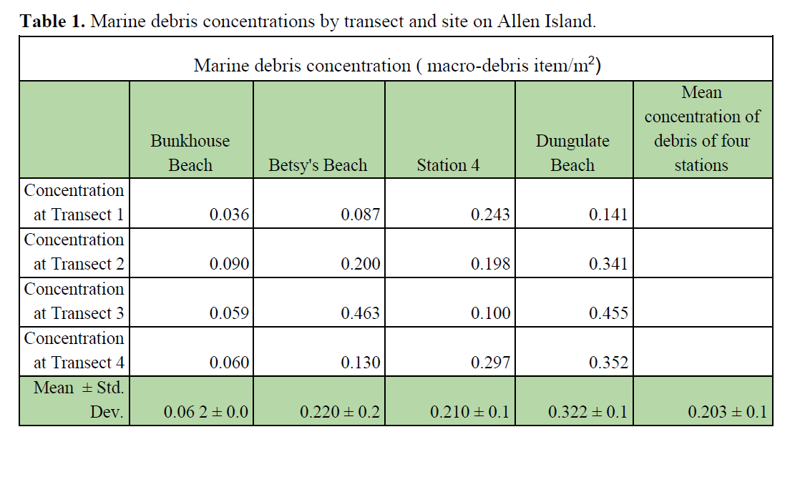

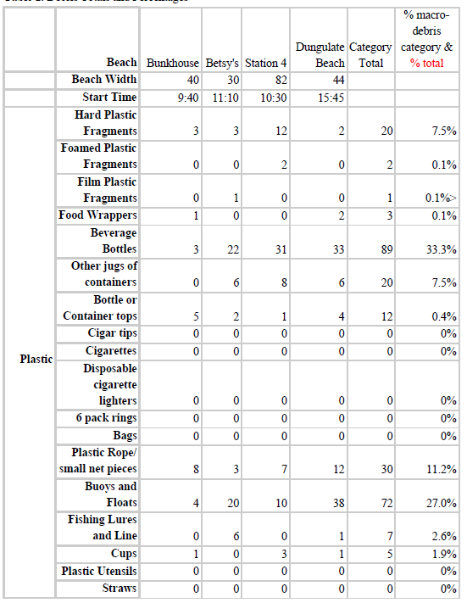Table A5.2 Debris totals and percentages

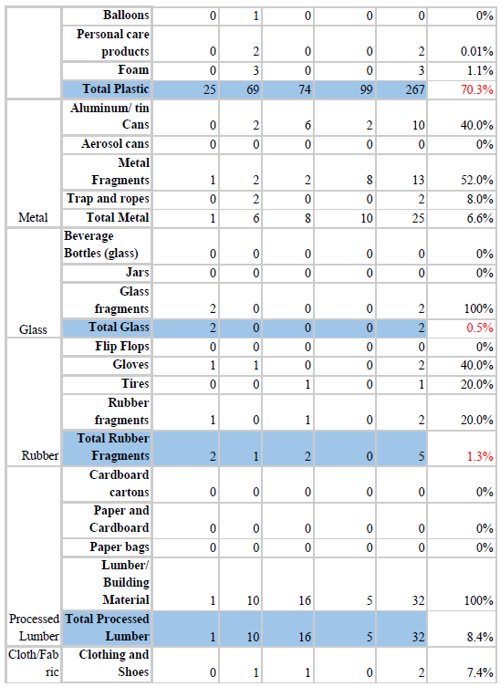

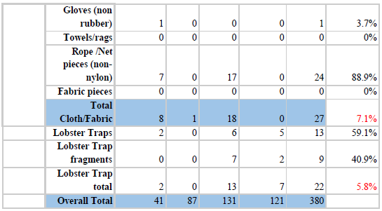

**Appendix 6 – Data from 2018 survey**

Table A6.1.Information about each sampling site. Sites sampled on September 25, 2018.

|  |  |  |  |  |
| --- | --- | --- | --- | --- |
| **Site** | **Starting Time** | **Average Shore Length (m)** | **Substrate** | **GPS Coordinates** |
| **1** | 9:50 | 23.5 | cobble | 43°52’36’’N 69°18’43’’W |
| **2** | 10:30 | 22.3 | cobble | 43°52’19’’N 69°19’1’’W |
| **3** | 11:30 | 20.7 | cobble | 43°52’14’’N 69°18’33’’W |
| **4** | 12:50 | 21.3 | rocky | 43°51'22"N 69°19'06"W |

Table A6.2**.** Debris items per m2. Sites sampled on September 25, 2018.

|  |  |  |  |  |
| --- | --- | --- | --- | --- |
| **Transect** | **Site 1** | **Site 2** | **Site 3** | **Site 4** |
| **1** | 0.37 | 1.17 | 1.05 | 0.02 |
| **2** | 0.61 | 1.39 | 0.97 | 0.00 |
| **3** | 0.62 | 1.12 | 0.24 | 0.00 |
| **4** | 0.34 | 1.89 | 0.82 | 0.00 |
| **Mean ± std. dev.** | **0.49 ± 0.15** | **1.39 ± 0.35** | **0.77 ± 0.37** | **0.01 ± 0.01** |

Table A6.3**.** Total debris items for each sampling site. Sites sampled on September 25, 2018.

|  |  |  |  |  |  |  |  |  |
| --- | --- | --- | --- | --- | --- | --- | --- | --- |
| **Macro debris** | | | **Site 1** | **Site 2** | **Site 3** | **Site 4** | **Category total** | **% category % total** |
| **Plastic** | Plastic Fragments | Hard | 18 | 64 | 12 | 0 | 94 | **14.2%** |
| Foamed | 8 | 10 | 19 | 0 | 37 | **5.6%** |
| Film | 5 | 0 | 7 | 0 | 12 | **1.8%** |
| Food wrappers | | 4 | 3 | 1 | 0 | 8 | **1.2%** |
| Beverage bottles | | 5 | 54 | 25 | 0 | 84 | **12.7%** |
| Other jugs or containers | | 2 | 14 | 7 | 0 | 23 | **3.5%** |
| Bottle or container caps | | 3 | 1 | 2 | 0 | 6 | **0.9%** |
| Cigar tips | | 0 | 0 | 0 | 0 | 0 | **0.0%** |
| Cigarettes | | 0 | 0 | 0 | 0 | 0 | **0.0%** |
| Disposable cigarette lighters | | 0 | 0 | 0 | 0 | 0 | **0.0%** |
| 6-pack rings | | 0 | 0 | 0 | 0 | 0 | **0.0%** |
| Bags | | 1 | 2 | 0 | 0 | 3 | **0.5%** |
| Plastic rope/small net pieces | | 19 | 68 | 17 | 0 | 104 | **15.7%** |
| Buoys and floats | | 19 | 37 | 34 | 0 | 90 | **13.6%** |
| Lures | | 0 | 0 | 0 | 0 | 0 | **0.0%** |
| Plastic cups (including Styrofoam) | | 1 | 1 | 0 | 0 | 2 | **0.3%** |
| Plastic utensils | | 0 | 0 | 0 | 0 | 0 | **0.0%** |
| Straws | | 0 | 0 | 0 | 0 | 0 | **0.0%** |
| Balloons | | 0 | 0 | 0 | 0 | 0 | **0.0%** |
| Personal care products | | 0 | 1 | 0 | 0 | 1 | **0.2%** |
| Other | | 41 | 7 | 3 | 0 | 51 | **7.7%** |
| **Total plastic** | | **161** | **336** | **165** | **0** | **662** | **81.5%** |
| **Glass** | Glass bottles | | 0 | 1 | 0 | 0 | 1 | **50.0%** |
| Glass jars | | 0 | 0 | 0 | 0 | 0 | **0.0%** |
| Glass fragments | | 1 | 0 | 0 | 0 | 1 | **50.0%** |
| Other | | 0 | 0 | 0 | 0 | 0 | **0.0%** |
| **Total glass** | | **1** | **1** | **0** | **0** | **2** | **0.2%** |
| **Metal** | Aluminum or tin cans | | 2 | 17 | 1 | 0 | 20 | **40.0%** |
| Aerosol cans | | 0 | 1 | 0 | 0 | 1 | **2.0%** |
| Metal fragments | | 13 | 7 | 2 | 1 | 23 | **46.0%** |
| Other | | 0 | 6 | 0 | 0 | 6 | **12.0%** |
| **Total metal** | | **15** | **31** | **3** | **1** | **50** | **6.2%** |
| **Rubber** | Flip-flops | | 0 | 0 | 1 | 0 | 1 | **12.5%** |
| Rubber gloves | | 0 | 2 | 0 | 0 | 2 | **25.0%** |
| Tires | | 0 | 0 | 0 | 0 | 0 | **0.0%** |
| Rubber fragments | | 2 | 0 | 0 | 0 | 2 | **25.0%** |
| Other | | 0 | 3 | 0 | 0 | 3 | **37.5%** |
| **Total rubber** | | **2** | **5** | **1** | **0** | **8** | **1.0%** |
| **Processed Lumber** | Cardboard | | 1 | 0 | 0 | 0 | 1 | **1.9%** |
| Paper bags | | 1 | 0 | 0 | 0 | 1 | **1.9%** |
| Lumber or building material | | 0 | 41 | 10 | 0 | 51 | **96.2%** |
| Other | | 0 | 0 | 0 | 0 | 0 | **0.0%** |
| **Total lumber** | | **2** | **41** | **10** | **0** | **53** | **6.5%** |
| **Cloth/fabric** | Clothing | | 0 | 0 | 0 | 0 | 0 | **0.0%** |
| Fabric gloves | | 0 | 0 | 0 | 0 | 0 | **0.0%** |
| Rags | | 0 | 0 | 0 | 0 | 0 | **0.0%** |
| Fabric rope | | 11 | 7 | 2 | 0 | 20 | **95.2%** |
| Fabric fragments | | 0 | 0 | 0 | 0 | 0 | **0.0%** |
| Other | | 0 | 1 | 0 | 0 | 1 | **4.8%** |
| **Total fabric** | | **11** | **8** | **2** | **0** | **21** | **2.6%** |
| **Other** | **Total other** | | 0 | 0 | 0 | 0 | 0 | **0.0%** |
| **Large debris items (>1 ft)** | **Total large debris items** | | 5 | 9 | 2 | 0 | 16 | **2.0%** |
| **Total debris items** |  | | **197** | **431** | **138** | **1** | **812** | **100%** |

**Appendix 7 – Data from 2019 survey**

Table A7.1 Information about each sampling site

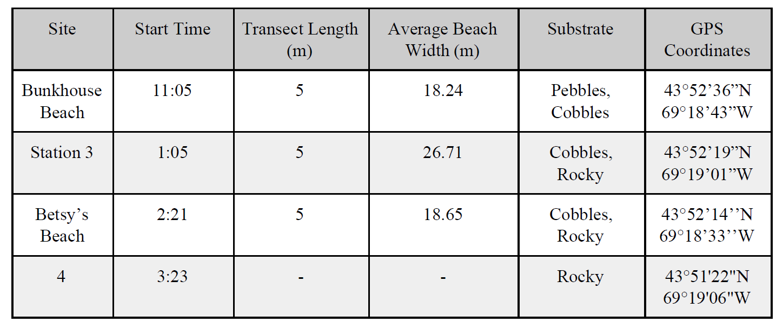

Table A7.2 Concentration of debris in number of debris items per m2 of each transect for sites sampled

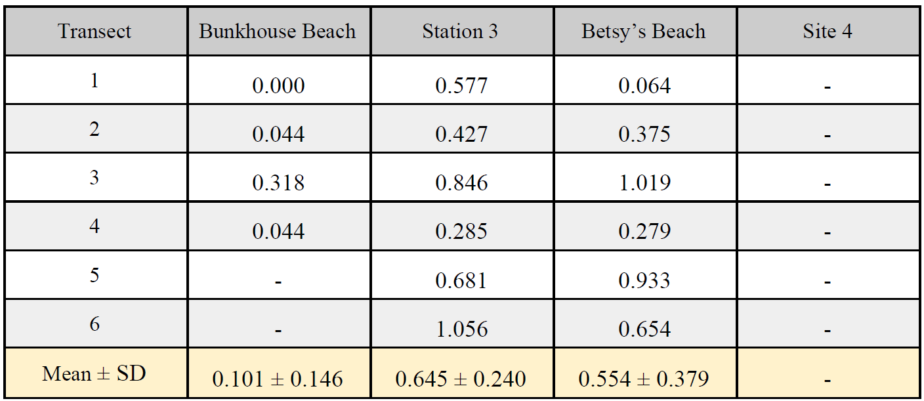

Table A7.3 Description of the types of debris observed on Allen Island at different sites with total debris in yellow.

